**Kiosk Questions**

Note: Use high good resolution image along with each question.

Front size and size must clear to all age group audience.

12 art object related questions. 35 questions.

**Darshan-Dwar Phulkari**

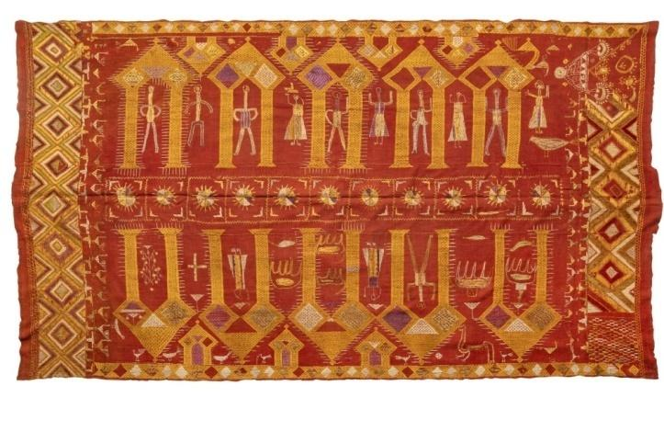

**Question1**: What is the style of this traditional embroidered textile from Punjab?

**A)**Kalamkari  
**B)** Phulkari  
**C)** Madhubani  
**D)** Warli

**Correct Answer:** **B) Phulkari**

**Question 2:** What is the purpose of Darshan Dwar Phulkari embroidery?

**A)** To decorate school bags  
**B)** To give as a religious offering in temples  
**C)** To cover books  
**D)** To use as carpets

**Answer:b) To give as a religious offering in temples**

**Question3:** What does "Darshan Dwar" mean?

**A)** Bright flowers  
**B)** Doorway to the Divine  
**C)** Big umbrella  
**D)** Dancing festival

**Answer:b) Doorway to the Divine**

**—---------------------------------------—---------------------------------------------------**

**Depiction of Ramayana**

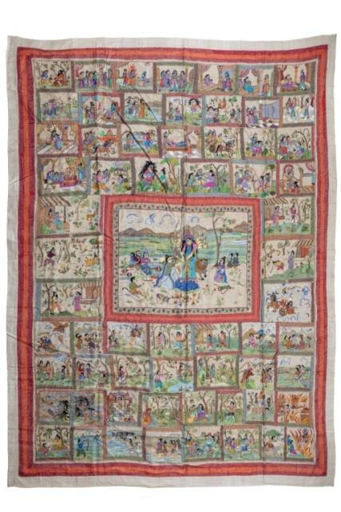

**Question 4:** What is the main theme depicted in this Kantha wall hanging?

1. The life of Buddha
2. The battle of Mahabharata
3. Akalbodhon- invoking Goddess Durga
4. The daily life of Bengali villagers

**Correct Answer: C) Akalbodhon – Rama invoking Goddess Durga**

**Question 5:** Can you count how many different scenes are depicted in this beautiful artwork? Look carefully at the large central scene and all the smaller ones around it!"

**Options:**  
A) 30  
B) 45  
C) 55  
D) 60

**Correct Answer: D)60**

—----------------------------------------------------------------------------------------------------

**Navagunjara Patiachitra**

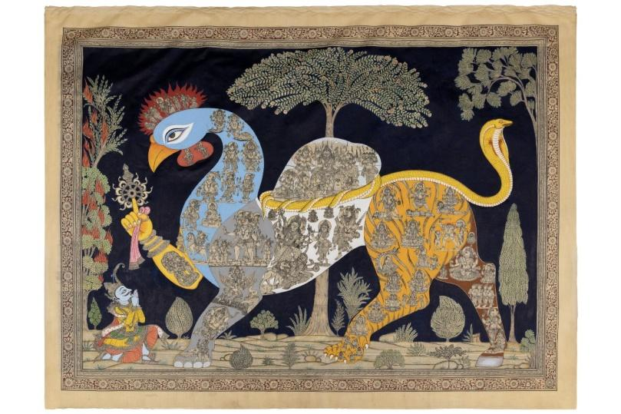

**Question 6:** The Navagunjara art form belongs to which Indian state?

**A)** Rajasthan  
**B)** Odisha  
**C)** Tamil Nadu  
**D)** West Bengal

**Correct Answer: B) Odisha**

**Question 7:** What is Navagunjara holding in its hand?

**A)** A bow and arrow  
**B)** A lotus flower  
**C)** A chakra   
**D)** A conch shell

**Correct Answer:** **C) A chakra**

**Question 8:** Navagunjara is a unique mythical creature made up of different animal parts. Can you match the correct animal parts to their respective positions from **left to right** in the figure?

**Head** , **Neck & Body**, **Hump**, **Front Left Leg** , **Front Right Leg (Holding Chakra)** ,**Back Left Leg** ,**Back Right Leg**.

**Options:**  
**A)** Peacock, Snake, Bull, Elephant, Human Hand, Deer, Tiger  
**B)** Elephant, Peacock, Bull, Snake, Tiger, Deer, Human Hand  
**C)** Bull, Snake, Peacock, Elephant, Human Hand, Tiger, Deer  
**D)** Tiger, Human Hand, Peacock, Snake, Bull, Deer, Elephant

**Correct Answer:**  
**A) Peacock, Snake, Bull, Elephant, Human Hand, Deer, Tiger** (Left to Right Order)

—-----------------------------------------------------------------------------------------------------

**Hanuman Dancing Mask**

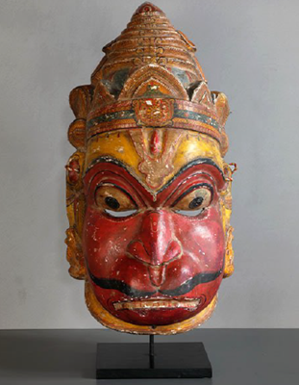

**Question 9:** What is the **Sahi Jata** festival of Puri known for?

**A)** Playing musical instruments  
**B)** Telling stories through dance  
**C)** Cooking traditional food  
**D)** Flying kites

**Correct Answer:** **B) Telling stories through dance**

**Question 10:** What is the main color traditionally used in Sahi Jata face masks?

**Options:**  
**A)** Blue  
**B)** Red  
**C)** Yellow  
**D)** Green

**Correct Answer:** B) Red

—-----------------------------------------------------------------------------------------------------

**Mumbai Lifestyle**

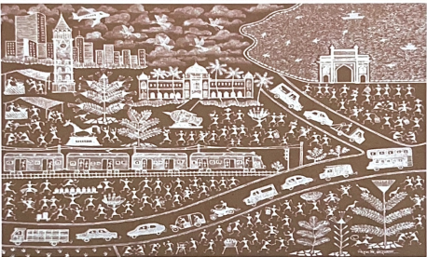

**Question 11:** How many autos and cars can you count in the 'Mumbai Lifestyle'- Warli painting? Look closely and find them all

**A)** 3 &5  
**B)** 1& 7  
**C)** 2& 10  
**D)** 1& 10

**Correct Answer: B) 1&7**

**Question 12:** In the "Mumbai Lifestyle" Warli painting by artist Kiran Vinayak Gorwala, which modes of transportation are depicted?

**A)** Road, rail and sea.  
**B)** Road & rail  
**C)** Road, rail, sea, air  
**D)** Road

**Correct Answer: C) Road, rail, sea, air  
—-----------------------------------------------------------------------------------------------------**

**Jumadi Bhuta Mask**

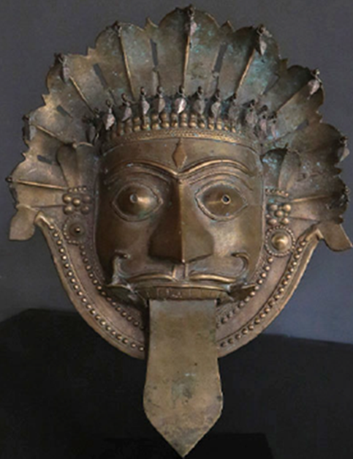

**Question 13:** This is a traditional mask used in rituals and performances. Can you guess which spirit deity it represents?

**A)** Hanuman **B)** Jumadi Bhuta  **C)** Ganesha **D)** Kali

**Correct Answer: Jumadi Bhuta**

**Question 14:** Can you count the number of cobra (snake) hoods shown on the headgear of the Jumadi Bhuta mask?"

**A)** 9 **B)** 8 **C)** 7 **D)** None

**Correct Answer: 9**

**Question 15:** Where do Jumadi Bhuta masks mainly belong to?

**A)** Rajasthan & Gujarat  
**B)** Karnataka & Kerala  
**C)** Tamil Nadu & Andhra Pradesh  
**D)** West Bengal & Odisha

**Correct Answer:** Karnataka & Kerala

**Question 16:** What is a distinctive feature often found on Jumadi Bhuta masks?

**A)** Cobra hoods **B)** Peacock feathers **C)** Tiger stripes **D)** Elephant tusks

**Correct Answer: Cobra hoods**

**—-----------------------------------------------------------------------------------------------------**

**Tree of Life**

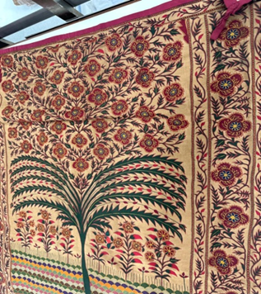

**Question 17: What is the Tree of Life also known as?**  
**A)** Banyan tree  
**B)** Mango tree  
**C)** Kalpavriksha, the wish-fulfilling tree  
**D)** Coconut tree

**Answer:** **c) Kalpavriksha, the wish-fulfilling tree**

**Question 18:** "The Tree of Life" – artwork from Rajasthan is an important symbol in many tribal and folk art forms. What does it usually represent?

**A)** A place for birds to sit **B)** The connection between nature and life **C)** A giant umbrella **D)** A magic tree that grants wishes

**Correct Answer: B) The connection between nature and life.**

**—-----------------------------------------------------------------------------------------------------**

**Dyamavva**

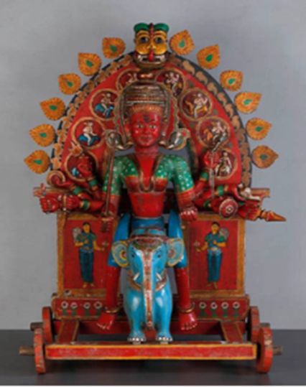

**Question 19:** The village deity Dyamavva (Durga) is shown riding what?  
**A)** Horse  
**B)** Lion  
**C)** Elephant  
**D)** Peacock

**Correct Answer: c) Elephant**

**Question 20:** Which craft tradition is used to make the Dyamavva (Durga) figure?  
**A)** Gond painting  
**B)** Kinhal craft  
**C)** Pattachitra  
**D)** Warli painting

**Correct Answer: b) Kinhal craft**

**—-----------------------------------------------------------------------------------------------------**

**Gond Art**

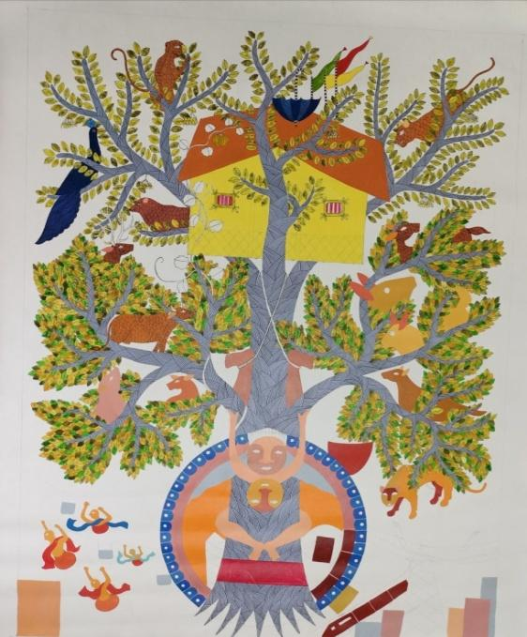 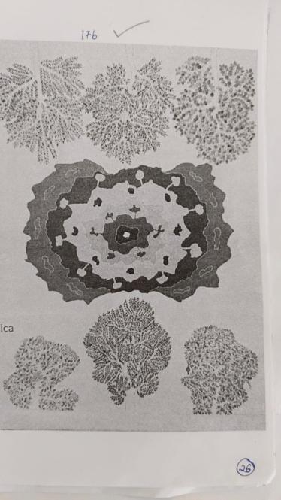

1. . (b)

**Question 21:** What is the main theme of the Gond painting ‘Alienated’?  
**A)** Celebrating city life  
**B)** Illegal Mining

**C)** Sports and games  
**D)** Festivals and celebrations

**Correct Answer:** **b) Illegal Mining**

**Question 22: Which state is home to the Gond community?**  
**A)** Rajasthan  
**B)** Madhya Pradesh  
**C)** Kerala  
**D)** Punjab

**Correct Answer:** **b) Madhya Pradesh**

—-----------------------------------------------------------------------------------------------------

**Chitrakathi: Epic narratives unfold Aranya Kanda of Ramayana**

**Question 23:** What is the meaning of the word "Chitrakathi"?  
**A)** Dancing teacher  
**B)** Story telling  
**C)** Music player  
**D)** Book writer

**Answer:** **B) Story telling**

**—-----------------------------------------------------------------------------------------------------**

**Varaha Avatara: The third incarnation of Vishnu**

**Question 24:** Which animal form does Vishnu take in the Varaha Avatara painting?  
**A)** Lion  
**B)** Fish  
**C)** Boar (Pig)  
**D)** Elephant

**Correct Answer:** **c) Boar (Pig)**

**Face Mast Image**

—-----------------------------------------------------------------------------------------------------

**Mata ni Pachedi**

**Question 25: Who creates the Mata ni Pachedi textile?**  
**A)** Warli community  
**B)** Vaghari community  
**C)** Chitrakar community  
**D)** Gond community

**Correct Answer:** **b) Vaghari community**

**—-----------------------------------------------------------------------------------------------------**